These review questions are for Bio 1 Energy and Metabolism topic. The questions were adapted from several sources, including the textbook’s review questions.

1) Which of the following is the definition of metabolism?
A) Metabolism is the harvesting of energy from breaking down ingested food.
B) Metabolism is an organism's adequate hydration.
C) Metabolism is all of an organism's molecules.
D) Metabolism is all the chemical reactions in an organism.
E) Metabolism is the maintenance of adequate temperature in an organism.

2) Which term most precisely describes the cellular process of breaking down large molecules into smaller ones?
A) reduction
B) metabolism
C) anabolism
D) dehydration
E) catabolism

3) What is the term for metabolic pathways that build up larger molecules from smaller molecules?
A) anabolic pathways
B) catabolic pathways
C) fermentation pathways
D) thermodynamic pathways
E) bioenergetic pathways

4) Which one of the following is true about anabolic pathways?
A) They do not depend on enzymes.
B) They are usually highly spontaneous chemical reactions.
C) They usually consume energy.
D) They release energy as they degrade polymers to monomers.
E) They consume energy to decrease the temperature of the organism and its environment.

5) Which of the following is an example of potential rather than kinetic energy?
A) the muscle contractions of a person mowing grass
B) water rushing over Niagara Falls
C) light flashes emitted by a firefly
D) a book on the top shelf of a book case
E) the flight of an insect foraging for food

6) Which of the following is true for all exergonic reactions?
A) The products have more potential energy than the reactants.
B) The reaction results in a decrease in potential energy.
C) A net input of energy from the surroundings is required for the reactions to proceed.
D) The reaction requires ATP

7) A chemical reaction where the product molecules have more potential energy than the reactant molecules is correctly described as
A) endergonic.
B) endothermic.
C) enthalpic.
D) spontaneous.
E) exothermic.

8) Which of the following statements is true concerning catabolic pathways?
A) They combine smaller molecules into larger molecules.
B) They usually produce energy, primarily in the form of ATP, for the cell's work.
C) They are endergonic.
D) They do not need enzyme catalysis.
E) They build up complex molecules such as protein from simpler compounds.

9) Nitrous oxide gas molecules (which are small and hydrophobic) moving directly through a cell's plasma membrane, from the high concentration side to the low concentration side, is an example of
A) diffusion.
B) facilitated diffusion.
C) active transport.
D) osmosis.
E) cotransport.

10) The movement of potassium ions from low concentration outside the cell to high concentration inside the cell requires...
A) transport of Cl- ions.
B) an energy source such as ATP.
C) a facilitated diffusion protein.
D) simultaneous osmosis of water molecules.

11) Which of the following membrane activities requires energy from ATP?
A) facilitated diffusion of chloride ions across the membrane through a chloride channel
B) movement of water into a cell by osmosis
C) Na+ ions moving out of a mammalian cell into a hypertonic Na⁺ solution.
D) movement of glucose molecules into a bacterial cell from a medium containing a higher concentration of glucose than inside the cell

12) Glucose diffuses slowly through artificial phospholipid bilayers. The cells lining the small intestine, however, rapidly move large quantities of glucose from the glucose-rich food into their glucose-poor cytoplasm. Using this information, which glucose transport mechanism is most probably functioning in the intestinal cells?
A) simple diffusion
B) endocytosis
C) active transport pumps
D) exocytosis
E) facilitated diffusion

13) When a carbon atom loses a bond to oxygen and replaces this bond with a bond to hydrogen, the organic molecule...
A) is oxidized and gains potential energy.
B) is reduced and loses potential energy.
C) is oxidized and loses potential energy.
D) is reduced and gains potential energy.
E) is not oxidized or reduced.

14) When all the carbon atoms in an organic molecule (such as glucose, molecular formula C₆H₁₂O₆) are converted into CO₂ molecules, the organic molecule...
A) is oxidized and ATP could have been produced from the process.
B) is reduced and ATP could have been consumed in the process.
C) is reduced and ATP could have been produced from the process.
D) is not oxidized or reduced. No ATP could have been consumed or produced.

15) When a glucose molecule loses a bond to a hydrogen atom but gains a bond to a carbon atom, the glucose molecule becomes
A) hydrolyzed.
B) hydrogenated.
C) oxidized.
D) reduced.
E) an oxidizing agent.

16) Which one of the following statements is true about enzyme-catalyzed reactions?
A) The reaction is faster than the same reaction in the absence of the enzyme.
B) The energy change of the reaction is opposite from the energy change that occurs in the absence of the enzyme.
C) The reaction is always spontaneous, whereas in the absence of enzyme it is non-spontaneous.
D) Enzyme-catalyzed reactions require ATP.
E) Enzyme-catalyzed reactions release more energy than non-enzyme reactions.

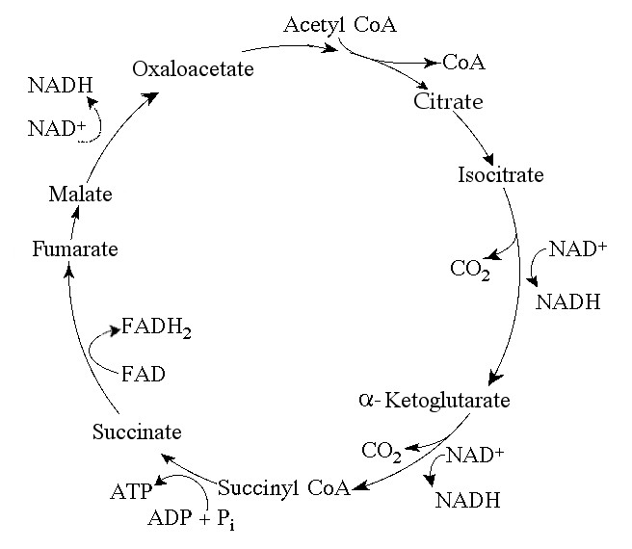

17) A circular metabolic pathway, such as the one shown above, is called a...
A) cycle.
B) feedback inhibition pathway.
C) feedback activation pathway.
D) metabolic circle.
E) closed pathway.

18) What is activation energy?
A) The thermal (kinetic) energy associated with random movements of molecules
B) The energy released through breaking chemical bonds
C) The difference in free energy (potential energy) between reactants and products
D) The energy required to initiate a chemical reaction

19) A solution of starch at room temperature does not readily decompose to form a solution of simple sugars because
A) the starch solution has less free energy than the sugar solution.
B) the hydrolysis of starch to sugar is endergonic.
C) the activation energy barrier for this reaction is too large at room temperature.
D) starch cannot be hydrolyzed in the presence of so much water.
E) starch hydrolysis is non-spontaneous.

20) Which one of the following statements regarding enzymes is true?
A) Enzymes increase the rate of a reaction by making the reaction more exergonic.
B) Enzymes increase the rate of a reaction by lowering the activation energy barrier.
C) Enzymes increase the rate of a reaction by reducing the rate of reverse reactions.
D) Enzymes change the equilibrium point of the reactions they catalyze.
E) Enzymes make the rate of a reaction independent of substrate concentrations.

21) During a laboratory experiment involving a chemical reaction, you discover that without enzymes present, the product molecules have lower potential energy than the reactant molecules. If you add an enzyme that catalyzes the reaction, then...
A) The products will have even less potential energy than without the enzyme present.
B) The products will have the same potential energy than without the enzyme present.
C) The products will have more potential energy than without the enzyme present.
D) The products will have more potential energy than the reactants
E) The reaction will not occur (the reactant and product molecules will be broken down by the enzyme).

22) Which is not one of the things that can occur at the active site of an enzyme?
A) Bind the substrate
B) Carry out a chemical reaction on the substrate molecule
C) Bind to allosteric regulatory molecules of the enzyme
D) Bind competitive inhibitor molecules of the enzyme
E) Hydrogen bonding between enzyme’s amino acids and the substrate molecule

23) Some of the drugs used to treat HIV patients are competitive inhibitors of the HIV reverse transcriptase enzyme. Unfortunately, the high mutation rate of HIV means that the virus rapidly acquires mutations with amino acid changes that make them resistant to these competitive inhibitors. Where in the reverse transcriptase enzyme would such amino acid changes most likely occur in drug-resistant viruses?
A) in or near the active site
B) at an allosteric site
C) at a cofactor binding site
D) in regions of the protein that determine packaging into the virus capsid
E) such mutations could occur anywhere with equal probability

24) How does an allosteric inhibitor decrease the rate of an enzyme reaction?
A) by binding at the active site of the enzyme
B) by changing the shape of the enzyme's active site
C) by changing the potential energy change of the reaction
D) by acting as a coenzyme for the reaction
E) by decreasing the activation energy of the reaction

25) In a typical example of feedback inhibition…
A) The first enzyme in a pathway is inhibited by its own product
B) The last enzyme in a pathway is inhibited by its own product
C) The first enzyme in a pathway is inhibited by the end product of the pathway
D) The last enzyme of the pathway is inhibited by the end product of the pathway

26) Protein kinases are enzymes that add phosphate functional groups to target proteins at specific sites. Phosphates can function as an on-off switch for a protein's activity, most likely through
A) the change in a protein's ionic R-group interactions leading to an active site shape change.
B) the change in a protein's charge leading to cleavage of the peptide chain.
C) a change in the optimal pH at which a reaction will occur.
D) a change in the optimal temperature at which a reaction will occur.
E) the excision of one or more peptides.

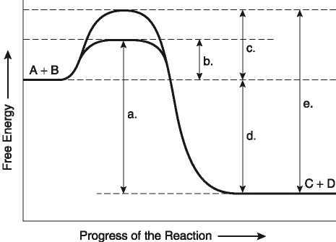

27) The following question is based on the chemical reaction A + B -> C + D shown in the figure above.

Which one of the following terms correctly describes the reaction above?
A) endergonic
B) exergonic
C) non-spontaneous
D) anabolic

28) The following question is based on the chemical reaction A + B -> C + D shown in the figure above.

Which arrow in the figure represents the net potential energy change of the molecules?
A) a
B) b
C) c
D) d
E) e

29) The following question is based on the chemical reaction A + B -> C + D shown in the figure above.

Which arrow in the figure would be the same in either an enzyme-catalyzed or a non enzyme catalyzed reaction?
A) a
B) b
C) c
D) d
E) e

30) The following question is based on the chemical reaction A + B -> C + D shown in the figure above.

Which arrow in the figure represents the activation energy required for the enzyme-catalyzed reaction?
A) a
B) b
C) c
D) d
E) e

31) The following question is based on the chemical reaction A + B -> C + D shown in the figure above.

Which arrow in the figure represents the activation energy required for the non-enzyme catalyzed reaction?
A) a
B) b
C) c
D) d
E) e

32) Succinate dehydrogenase enzyme catalyzes the conversion of succinate to fumarate. The reaction is inhibited by malonic acid, which resembles succinate but cannot be acted upon by succinate dehydrogenase enzyme. Increasing the ratio of succinate to malonic acid reduces the inhibitory effect of malonic acid.

Based on this information, which of the following is correct?
A) Fumarate is the substrate.
B) Malonic acid is the substrate.
C) Succinate is the substrate, and fumarate is the product.
D) Fumarate is the product, and malonic acid is a noncompetitive inhibitor.
E) Malonic acid is the product, and fumarate is a competitive inhibitor.

33) Succinate dehydrogenase enzyme catalyzes the conversion of succinate to fumarate. The reaction is inhibited by malonic acid, which resembles succinate but cannot be acted upon by succinate dehydrogenase. Increasing the ratio of succinate to malonic acid reduces the inhibitory effect of malonic acid.

What is malonic acid's role with respect to succinate dehydrogenase enzyme?
A) It is a competitive inhibitor.
B) It blocks the binding of fumarate.
C) It is a noncompetitive inhibitor.
D) It is able to bind to succinate.
E) It is an allosteric regulator.

34) A series of enzymes catalyze the reaction X -> Y -> Z -> A. Product A binds to the enzyme that converts X to Y at a position remote from the enzyme’s active site. This binding decreases the activity of the enzyme.

Substance X is the metabolic pathway’s...
A) coenzyme
B) allosteric inhibitor
C) substrate
D) intermediate
E) product

35) A series of enzymes catalyze the reaction X -> Y -> Z -> A. Product A binds to the enzyme that converts X to Y at a position remote from the enzyme’s active site. This binding decreases the activity of the enzyme.

With respect to the enzyme that converts X to Y, substance A functions as
A) a coenzyme.
B) an allosteric inhibitor.
C) the substrate.
D) an intermediate.
E) a product.

36) Based on our discussion of anabolic and catabolic reactions, which of the following metabolic processes would you guess is a source of energy for the cell?
A) Nucleotides -> nucleic acids
B) C₆H₁₂O₆ + 6O₂ -> 6CO₂ + 6H₂O
C) 6CO₂ + 6H₂O -> C₆H₁₂O₆ + 6O₂
D) amino acids -> protein
E) glucose + fructose -> sucrose

37) When ATP releases energy, which two product molecules are created from the ATP molecule?
A) a water molecule and a protein
B) a protein and kinetic energy
C) kinetic energy and inorganic phosphate ion
D) an inorganic phosphate ion and ADP

38) Where is the energy stored in an ATP molecule?
A) Within the bonds between nitrogen and carbon
B) In the carbon to carbon bonds of the ribose
C) In the bond between the last two phosphate groups
D) In the fatty acid portion

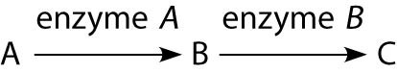

39) The figure above shows a simple metabolic pathway.

If a mutation occurred that prevented enzyme A from functioning, which of the following would be a consequence of that mutation?
A) an accumulation of A and no production of B and C
B) an accumulation of A and B and no production of C
C) an accumulation of B and no production of A and C
D) an accumulation of B and C and no production of A
E) an accumulation of C and no production of A and B

40) The previous figure shows a simple metabolic pathway.

If molecules A, B, and C are all required by bacteria for proper growth, and if a certain strain of bacteria was mutant for the gene-encoding enzyme A (no enzyme A is made), that bacteria would be able to grow on which of the following media? (Media = food source for bacteria)
A) minimal medium (no A, no B, and no C)
B) minimal medium supplemented with nutrient A only
C) minimal medium supplemented with nutrient B only
D) minimal medium supplemented with nutrient C only
E) minimal medium supplemented with nutrients A and B

41) The previous figure shows a simple metabolic pathway.

If molecules A, B, and C are all required by bacteria for proper growth, and if a certain strain of bacteria was mutant for the gene-encoding enzyme B (no enzyme B is made), that bacteria would be able to grow on which of the following media?
A) minimal medium supplemented with nutrients A and B
B) minimal medium supplemented with A only
C) minimal medium supplemented with B only
D) minimal medium supplemented with C only
E) minimal medium supplemented with nutrients A and C

42) The previous figure shows a simple metabolic pathway.

If only molecule C is required by bacteria for proper growth, and if a certain strain of bacteria was mutant for the gene-encoding enzyme A (no enzyme A is made), that bacteria would not be able to grow on which of the following media?
A) minimal medium supplemented with nutrients A, B, or C
B) minimal medium supplemented with nutrient A only
C) minimal medium supplemented with nutrient B only
D) minimal medium supplemented with nutrient C only

43) The previous figure shows a simple metabolic pathway.

If only molecule C is required by bacteria for proper growth, and if a certain strain of bacteria was mutant for the gene-encoding enzyme B (no enzyme B is made), that bacteria would be able to grow on which of the following media?
A) minimal medium supplemented with nutrients A and B
B) minimal medium supplemented with nutrient A only
C) minimal medium supplemented with nutrient B only
D) minimal medium supplemented with nutrient C only

44) The effect of increased temperature or altered pH from an enzyme’s optimum temperature or pH is that...
A) The enzyme hydrolyses into separated amino acids
B) The enzyme becomes permanently attached to its substrate
C) The three dimensional shape of the enzyme changes
D) The rate of the enzyme increases

Answers to multiple choice questions:

1) D
2) E
3) A
4) C
5) D
6) B
7) A
8) B
9) A
10) B
11) C
12) E
13) D
14) A
15) C
16) A
17) A
18) D
19) C
20) B
21) B
22) C
23) A
24) B
25) C
26) A
27) B
28) D
29) D
30) B
31) C
32) C
33) A
34) C
35) B
36) B
37) D
38) C
39) A
40) E
41) E
42) B
43) D
44) C

