These review questions are for Bio 1 Virus and Prokaryotes topic. The questions were adapted from several sources, including the textbook’s review questions.

1) All viruses contain...
A) A membrane and a chromosome
B) A chromosome and a nucleus
C) A nucleus and a capsid
D) A capsid and a chromosome
E) Cytoplasm and a membrane

2) Which one of the following characteristics, structures, or processes is common to both bacteria and viruses?
A) metabolism
B) ribosomes
C) genetic material composed of nucleic acid
D) cell division
E) capsid

3) A virus' host range (the species and cell types that the virus can infect) is determined by...
A) the enzymes carried by the virus.
B) whether its nucleic acid is DNA or RNA.
C) the proteins in the host's cytoplasm.
D) the enzymes produced by the virus before it infects the cell.
E) the proteins on the capsid and the proteins on host cell membranes.

4) In order for a DNA virus to replicate inside a cell, what part of the virus must enter the cell?
A) The chromosome
B) The capsid
C) Reverse transcriptase
D) RNA-dependent RNA polymerase
E) cRNA

5) A bacteria is infected with an experimentally constructed virus composed of the T2 virus protein coat (capsid) and the T4 virus chromosome. The new viruses produced inside the bacteria would have...
A) T2 protein and T4 DNA.
B) T2 protein and T2 DNA.
C) a mixture of the DNA and proteins of both viruses.
D) T4 protein and T4 DNA.
E) T4 protein and T2 DNA.

6) Which of the following is characteristic of the lytic cycle?
A) The virus causes infected cells to undergo mitosis.
B) Viral DNA is incorporated into the host genome.
C) The viral genome replicates without destroying the host cell.
D) A large number of viruses are released when the cell bursts.
E) The virus can exist in the cell for years without producing any effects on the cell.

7) Which viruses always have an RNA chromosome that acts as a template for DNA synthesis?
A) lytic phages
B) proviruses
C) prokaryotes
D) bacteriophages
E) retroviruses

8) What is the function of reverse transcriptase in retroviruses?
A) It hydrolyzes the host cell's DNA.
B) It uses viral RNA as a template for DNA synthesis.
C) It converts host cell RNA into viral DNA.
D) It translates viral RNA into proteins.
E) It uses viral RNA as a template for making complementary RNA strands.

9) For a DNA virus, the copies of the viral DNA are made by ______ and the viral mRNA is made by ________.
A) Host cell enzymes, Host cell enzymes
B) Host cell enzymes, Viral enzymes
C) Viral cell enzymes, Viral enzymes
D) Viral cell enzymes, Host cell enzymes
E) Nothing in both blanks (Viruses self-reproduce inside host cells.)

10) RNA viruses require their own supply of certain enzymes because...
A) host cells rapidly destroy the viruses.
B) host cells lack enzymes that can replicate the viral genome.
C) these enzymes translate viral mRNA into proteins.
D) these enzymes penetrate host cell membranes.
E) these enzymes cannot be made in host cells.

11) Certain viruses have an enzyme called RNA-dependent RNA polymerase packed inside their capsid (along with the virus’ chromosome). This type of virus...
A) Is a retrovirus.
B) Makes a DNA copy of its RNA chromosome and inserts the cDNA into the host cell chromosomes.
C) Has a DNA chromosome.
D) Transcribes mRNA from its RNA chromosome.
E) Relies on the host cell to transcribe its genes into mRNA.

12) A person becomes inflected with the herpes virus, which is a DNA virus. The viral infection causes sores on their person's lips and genitals. After a few days these sores go away. But every few years for the rest of the person's life the sores reappear. Which of the following accounts for why the person who has had a herpes virus infection keeps getting flare-ups of the sores for the rest of their life?
A) The person gets infected by a closely related herpe virus of a different strain
B) The person gets re-infected by the same herpe svirus strain
C) The person gets infected co-infected with an unrelated virus that causes the same sores
D) Copies of the herpes virus genome are latent in the host cell chromosomes
E) Copies of the intact herpes virus are latent in the host cell cytoplasm

13) Which statement about the genomes of prokaryotes is correct?
A) Prokaryotic genomes are diploid throughout most of the cell cycle.
B) Prokaryotic chromosomes are sometimes called plasmids.
C) Prokaryotic cells have multiple chromosomes, "packed" with a relatively large amount of protein.
D) The prokaryotic chromosome is protected by a small cell wall that is inside the outer cell wall.
E) Prokaryotic genomes are composed of circular DNA.

14) Which of these statements is correct?
A) When bacteria conjugate, they mutually exchange genetic material.
B) Bacteria genetic material is confined within vesicles known as plasmids.
C) Prokaryotes divide by binary fission, without mitosis or meiosis.
D) Archaea sexually reproduce but bacteria do not.
E) Bacteria sexually reproduce but archaea do not.

15) Prokaryotes are divided into ____ (a number) of domains. The names of these domains are ______.
A) 3, archaea, bacteria, and eukaryea
B) 2, archaea and bacteria
C) 4, plants, animals, fungi, and protista
D) 5, plants, animals, fungi, Protista, and prokaryotes
E) 2, prokaryotes and eukaryotes

16) Which statement about the domain Archaea is false?
A) Archaea membrane lipids differ from those of bacteria.
B) Some archaea can make methane.
C) The genomes of archaea are linear chromosomes, similar but smaller than eukaryotic
chromosomes.
D) Some archaea can inhabit solutions of higher salt concentration than bacteria.
E) Some archaea can inhabit solutions of higher temperature than bacteria.

17) Which prokaryotes should be expected to be most strongly resistant to plasmolysis (water loss) in hypertonic environments?
A) halophiles
B) thermophiles
C) methanogens
D) cyanobacteria
E) nitrogen-fixing bacteria that live in legume root nodules

18) The thermoacidophile, Sulfolobus acidocaldarius, lacks peptidoglycan, but still possesses a cell wall. What is likely to be true of this species?
1. It is a bacterium.
2. It is an archaean.
3. The optimal pH of its enzymes will lie above pH 7.
4. The optimal pH of its enzymes will lie below pH 7.
5. It could inhabit certain hydrothermal springs.
6. It could inhabit alkaline hot springs.
A) 1, 3, and 6
B) 2, 4, and 6
C) 2, 4, and 5
D) 1, 3, and 5
E) 1, 4, and 5

19) Which of these cell traits is not a feature of halophiles?
A) the ability to grow in an extremely acidic pH environment
B) cell walls that lack peptidoglycan
C) cells that are isotonic to the salty conditions where the halophile naturally is found
D) high concentration of organic solutes in the cytoplasm

20) A certain archaea is a thermoacidophile. Which of the graphs below most accurately depicts the expected temperature and pH profiles of its enzymes? (Note: The curves on these graphs show pH as a dotted line and temperature as a solid line.)

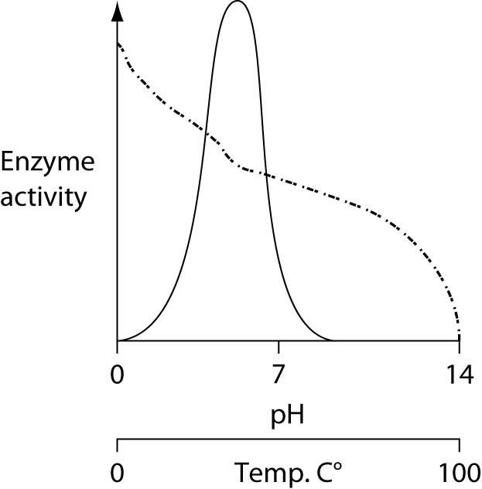
A) C)
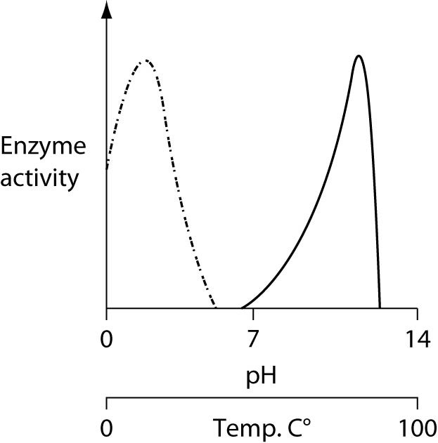
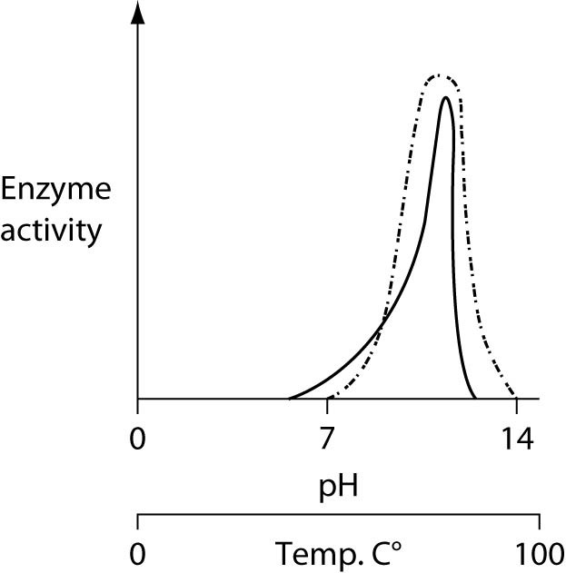
B) D)
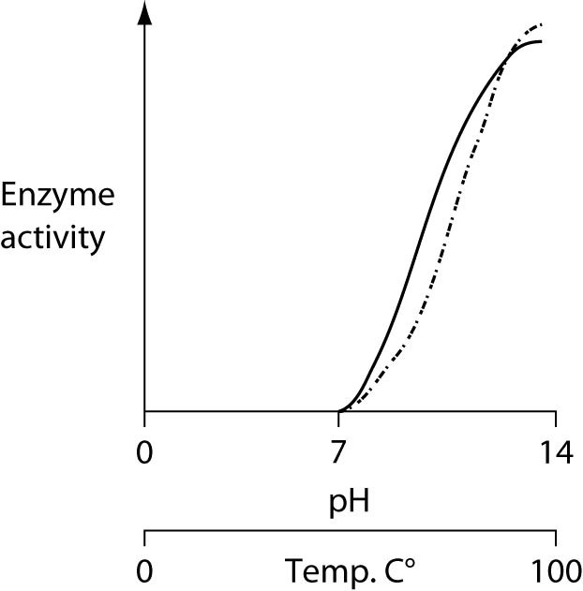

A) A
B) B
C) C
D) D

21) Which statement about bacterial cell walls is false?
A) Bacterial cell walls differ in molecular composition from plant cell walls.
B) Cell walls prevent cells from bursting in hypotonic environments.
C) Cell walls of bacteria are made of chitin, whereas plant cell walls are made of cellulose.
D) Bacterial cell walls absorb Gram’s stain.
E) Carbohydrates are part of bacteria cell walls.

22) Gram-negative bacteria species are gram negative because they have a thin...
A) chromosome
B) sex pilus
C) plasma membrane
D) cell wall
E) capsid

23) Which of the following was not described in lecture as an activity of bacteria?
A) causing diseases
B) breaking down organic matter
C) adding methane to the atmosphere
D) performing photosynthesis

24) If all bacteria on Earth suddenly vanished, which of the following would be the most likely and most direct result?
A) The number of individual organisms on Earth would decrease by about 10%’
B) Human populations would thrive in the absence of disease.
C) Virus numbers would dramatically increase.
D) The recycling of nutrients would be greatly reduced.
E) There would be no more pathogens on Earth.

25) Which prokaryote would be gram positive?
A) Methanogens
B) Cyanobacteria
C) Acidophile archaea
D) Bacteria with plasmids
E) Thick cell wall bacteria

26) Which prokaryote is known for its ability to do photosynthesis?
A) Methanogens
B) Cyanobacteria
C) Thin cell wall bacteria
D) Bacteria with plasmids
E) Thick cell wall bacteria

27) Which prokaryote is most likely to be found both in sewage treatment plants and in the intestines of cattle?
A) Methanogens
B) Cyanobacteria
C) Thin cell wall bacteria
D) Bacteria with plasmids
E) Thick cell wall bacteria

28) Which prokaryote is most likely to have genes for antibiotic resistance?
A) Methanogens
B) Cyanobacteria
C) Thin cell wall bacteria
D) Bacteria with plasmids
E) Thick cell wall bacteria

29) Which of the following statements is not true?
A) Archaea and bacteria have different membrane lipids.
B) Both archaea and bacteria lack membrane-enclosed organelles.
C) The cell walls of archaea lack peptidoglycan.
D) Bacteria live in more extreme environments that Archaea
E) Archaea were initially classified as a type of bacteria

30) Which of the following does not involve bacteria gaining new genes from other bacteria?
A) transduction
B) conjugation
C) transformation
D) binary fission

31) Which method of gene transfer mechanism involves viruses?
A) transduction.
B) transformation.
C) conjugation.
D) binary fission.
E) endosymbiosis.

32) If a bacteria does not possess any plasmids the bacteria will probably also...
A) lack antibiotic-resistance.
B) lack a cell wall.
C) lack a chromosome.
D) lack water in its cytoplasm.
E) be unable to survive in its normal environment.

33) In a hypothetical situation, the genes for sex pilus construction and for tetracycline (an antibiotic) resistance are located together on the same plasmid within a particular bacterium. If this bacterium readily performs conjugation involving a copy of this plasmid, then the result should be...
A) a bacterium that has undergone transduction.
B) the rapid spread of tetracycline resistance to other bacteria in that habitat.
C) the subsequent loss of tetracycline resistance from this bacterium.
D) the production of offspring from mating with other bacteria.
E) the temporary possession by this bacterium of a completely diploid genome.

34) If a population of E. coli lacks the F factor and if bacteriophages are excluded from the bacterial cultures, then which of these is a means by which beneficial mutations might be transmitted from one bacteria to another?
A) via sex pili
B) via transduction
C) via conjugation
D) via transformation

35) Changes in the genes that a bacteria possesses cannot result from...
A) transduction.
B) transformation
C) conjugation
D) mutation.
E) meiosis.

36) A group of several genes controlled by a single promoter is called
A) an operon.
B) an enhancer.
C) a polypeptide.
D) a repressor.
E) an activator.

37) In response to molecules in their environment (such as amino acids and sugars), prokaryotes can do which of the following?
A) turn off translation of their mRNA
B) alter the level of production of various enzymes
C) increase the number and responsiveness of their ribosomes
D) inactivate mRNA molecules that have already been transcribed but not yet translated
E) alter the sequence of amino acids in certain proteins

38) Operons like the Trp operon are controlled through repression of the operon. In operons such as this, there is a molecule called a co-repressor that...
A) binds to the promoter region and decreases the affinity of RNA polymerase for the promoter.
B) binds to the operator region and blocks the attachment of RNA polymerase to the promoter.
C) increases the production of inactive repressor proteins.
D) binds to the repressor protein and inactivates it.
E) binds to the repressor protein and activates it.

39) The tryptophan operon is an operon that is...
A) permanently turned on.
B) turned on only when tryptophan is present in the growth medium.
C) turned off only when glucose is present in the growth medium.
D) turned on only when glucose is present in the growth medium.
E) turned off whenever tryptophan is added to the growth medium.

40) A mutation that inactivates the gene for a repressor protein of a repressible operon (such as the tryptophan operon) would result in...
A) continuous transcription of the genes controlled by that repressor protein.
B) complete inhibition of transcription of the genes controlled by that repressor protein.
C) irreversible binding of the repressor to the operator.
D) inactivation of RNA polymerase by alteration of its active site.
E) continuous translation of the mRNA because of alteration of the mRNA structure.

41) For a repressible operon (such as the tryptophan operon) to be transcribed, which of the following must occur?
A) A corepressor must be present.
B) RNA polymerase and the active repressor must be present.
C) RNA polymerase must bind to the promoter, and the repressor must be inactive.
D) RNA polymerase cannot be present, and the repressor must be inactive.
E) RNA polymerase must not occupy the promoter, and the repressor must be inactive.

42) If a particular operon encodes enzymes for making a certain amino acid and the operon is regulated like the trp operon, then which of the following is true?
A) the amino acid inactivates the repressor.
B) the repressor is active in the absence of the amino acid.
C) the amino acid is called a corepressor.
D) the amino acid turns on transcription of the operon.

43) Which of the following, when taken up by the cell, binds to the repressor so that the repressor no longer binds to the operator?
A) ubiquitin
B) inducer
C) promoter
D) repressor
E) corepressor

44) If there was a mutation in the gene for the lac operon's repressor protein that resulted in the lac operon being permanently repressed, which of these would most likely characterize the mutant protein?
A) The repressor protein cannot bind to the operator.
B) The gene for the repressor protein does not encode a functional repressor.
C) The repressor protein cannot bind to the inducer protein.
D) The repressor protein binds to another repressor protein.
E) The gene for the repressor protein binds to the operator sequence of the operon.

45) Suppose an experimenter becomes proficient with a technique that allows her to move DNA sequences within a prokaryotic genome.

If she moves the promoter for the lac operon to the region between the beta galactosidase gene and the permease gene (these are two of the three genes within the lac operon) which of the following would be likely?
A) None of the three genes of the operon will be expressed.
B) RNA polymerase will no longer transcribe beta galactosidase
C) Permease will be produced regardless of what sugars are present
D) All of the three genes of the operon will be expressed.

46) Suppose an experimenter becomes proficient with a technique that allows her to move DNA sequences within a prokaryotic genome.

If she moves the operator to the far end of the operon (passed the final gene, which is called the transacetylase gene), which of the following would likely occur when the cell is exposed to lactose?
A) The inducer will no longer bind to the repressor.
B) The repressor will no longer bind to the operator.
C) The operon will never be transcribed.
D) The operon genes will be transcribed continuously.
E) The repressor protein will no longer be produced.

47) Suppose an experimenter becomes proficient with a technique that allows her to move DNA sequences within a prokaryotic genome.

If she moves the repressor gene (including the repressor gene's promoter) to a position several thousand base pairs away from its normal position, which will you expect to occur?
A) The repressor will no longer be made.
B) The repressor will no longer bind to the operator.
C) The repressor will no longer bind to the inducer.
D) The lac operon will be expressed continuously.
E) The lac operon will function normally.

48) Suppose an experimenter becomes proficient with a technique that allows her to move DNA sequences within a prokaryotic genome.

If she moves the operator to a position far upstream from the promoter, what would occur?
A) The trp operon will function normally.
B) The trp operon will be expressed continuously.
C) The repressor will not be able to bind to the operator.
D) The repressor will bind to the promoter.
E) The repressor will no longer be made.

49) Most repressor proteins are allosterically regulated. Which of the following binds with repressors to alter the repressor conformation?
A) inducer and co-repressor
B) co-repressor and RNA polymerase
C) RNA polymerase and transcription factors
D) transcription factors amd cAMP
E) cAMP and inducer

50) In several sugar-metabolism-related operons (such as the Lac operon), the catabolite activator protein (CAP) binds to DNA to stimulate transcription. What causes an increase in CAP activity?
A) increase in glucose and increase in cAMP
B) decrease in glucose and increase in cAMP
C) increase in glucose and decrease in cAMP
D) decrease in glucose and increase in repressor
E) decrease in glucose and decrease in repressor

51) The lactose operon is likely to be transcribed when...
A) there is more glucose in the cell than lactose.
B) the cyclic AMP levels are low.
C) there is glucose but no lactose in the cell.
D) the cyclic AMP and lactose levels are both high within the cell.
E) the cAMP level is high and the lactose level is low.

52) Transcription of the genes the Lac operon...
A) occurs continuously whenever the inducer and CAP are present in the cell.
B) starts when the Lactose metabolic pathway's substrate is present.
C) starts when the Lactose metabolic pathway's endproduct is present.
D) stops when the Lactose metabolic pathway's endproduct is present.
E) does not result in the production of enzymes.

53) Which statement best describes how operons benefit a bacteria?
A) Operons organize gene expression so that the genes are expressed under all conditions
B) Operons allow each gene in the genome to be expressed an equal number of times as all other genes
C) Operons allow the organism to adjust to changes in environmental conditions
D) Operons allow young organisms to respond differently from more mature organisms
E) Operons allow environmental changes to alter the prokaryote's genome sequence

54) Which of the following is a protein that regulates gene expression in the Lac and Trp operons?
A) operon
B) inducer
C) promoter
D) repressor
E) corepressor

55) If a cell was missing _____ for one of its operons then the result would be that the cell would continuously express the genes of the operon.
A) The corepressor
B) The inducer
C) The promoter
D) Ubiquitin

56) If glucose is available in the environment of a bacteria, then the bacteria will have a very low concentration of the second messenger cAMP in its cytoplasm. When glucose is not available, the cAMP increases in concentration and it binds to the CAP protein. Which of the following would you expect to be an effect of cAMP binding to the CAP protein?
A) decreased concentration of the lac enzymes
B) increased concentration of the trp enzymes
C) decreased binding of the RNA polymerase to the Lac promoter
D) decreased use of lactose in the cell
E) increased use of lactose in the cell

57) What would occur if the repressor of the Trp operon were mutated so it could not bind the operator?
A) irreversible binding of the repressor to the promoter
B) reduced transcription of the operon's genes
C) buildup of lactose inside the cell
D) continuous transcription of the operon's genes
E) overproduction of catabolite activator protein (CAP)

58) What would occur if lactose was present, glucose was not present, and the CAP protein of the Lac operon were mutated so it could not bind to the promoter?
A) irreversible binding of the repressor to the promoter
B) no transcription of the operon's genes
C) buildup of a substrate for the pathway controlled by the operon
D) continuous transcription of the operon's genes
E) overproduction of catabolite activator protein (CAP)

Answers to review questions:

1) D
2) C
3) E
4) A
5) D
6) D
7) E
8) B
9) A
10) B
11) D
12) D
13) E
14) C
15) B
16) C
17) A
18) C
19) A
20) A
21) C
22) D
23) C
24) D
25) E
26) B
27) A
28) D
29) D
30) D
31) A
32) A
33) B
34) D
35) E
36) A
37) B
38) E
39) E
40) A
41) C
42) C
43) B
44) B
45) B
46) C
47) E
48) B
49) A
50) B
51) D
52) A
53) C
54) D
55) A
56) E
57) D
58) B

