These review questions are for Bio 1 Water topic. The questions were adapted from several sources, including the textbook’s review questions.

Multiple choice review questions:

1) The molecular formula for a water molecule is
A) W
B) H²O
C) 2HO
D) H₂O

2) In a single molecule of water, two hydrogen atoms are bonded to a single oxygen atom by
A) hydrogen bonds.
B) nonpolar covalent bonds.
C) polar covalent bonds.
D) ionic bonds.
E) van der Waals interactions.

3) The slight negative charge at one end of one water molecule is attracted to the slight positive charge of another water molecule. What is this attraction called?
A) a covalent bond
B) a hydrogen bond
C) an ionic bond
D) a hydrophilic bond
E) a van der Waals interaction

4) The partial negative charge in a molecule of water occurs because
A) the oxygen atom acquires an additional electron.
B) the electrons shared between the oxygen and hydrogen atoms spend more time around the oxygen atom nucleus than around the hydrogen atom nucleus.
C) the oxygen atom has two pairs of electrons in its valence shell that are not neutralized by hydrogen atoms.
D) the oxygen atom forms hybrid orbitals that distribute electrons unequally around the oxygen nucleus.
E) one of the hydrogen atoms donates an electron to the oxygen atom.

5) Water molecules are able to form hydrogen bonds with
A) compounds that have polar covalent bonds.
B) oils.
C) oxygen gas (O₂) molecules.
D) chloride ions.
E) any compound that is not soluble in water.

6) Which type of bond must be broken for water to vaporize?
A) ionic bonds
B) both hydrogen bonds and ionic bonds
C) polar covalent bonds
D) hydrogen bonds
E) both polar covalent bonds and hydrogen bonds

7) Why does evaporation of water from a surface cause cooling of the surface?
A) The breaking of hydrogen bonds between water molecules requires heat energy.
B) The water molecules with the most heat energy evaporate more slowly.
C) The solute molecules left behind absorb heat.
D) Water molecules absorb solutes from the surface in order to acquire enough energy to evaporate.
E) The expansion of water vapor extracts heat from the surface.

8) Many mammals control their body temperature by sweating. Which property of water is most directly responsible for the ability of sweat to lower body temperature?
A) water's change in density when it condenses
B) water's ability to dissolve molecules in the air
C) the release of heat by the formation of hydrogen bonds
D) the absorption of heat by the breaking of hydrogen bonds
E) water's high surface tension

9) A molecule with many polar covalent bonds would
A) Be soluble in water
B) Not be soluble in water
C) Contain atoms with very similar electronegativity (pull on electrons)
D) Contain atoms that gained or lost electrons

10) If a gecko relied on hydrogen bonds to cling to surfaces, what type of surface would cause the most problems for this animal?
A) a surface coated with a thin film of water
B) a surface made with carbon and hydrogen atoms covalently bonded together
C) a surface made with carbon, hydrogen, and oxygen atoms covalently bonded together
D) a surface made with carbon, hydrogen, nitrogen, and oxygen atoms covalently bonded together
E) a surface made with carbon and nitrogen and hydrogen atoms covalently bonded together

11) Which bond or interaction will always form when a polar covalent molecule is put into water?
A) covalent bond
B) hydrogen bond
C) van der Waals interaction
D) ionic bond
E) either covalent bonds or ionic bonds

12) Which of the following is the weakest bond type?
A) a covalent bond
B) a hydrogen bond
C) an ionic bond

13) Hydrophobic substances such as vegetable oil are
A) nonpolar substances that repel water molecules.
B) nonpolar substances that have an attraction for water molecules.
C) polar substances that repel water molecules.
D) polar substances that have an affinity for water.
E) charged molecules that hydrogen-bond with water molecules.

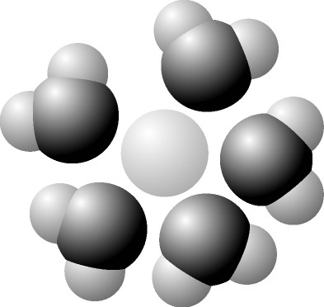

14) Based on your knowledge of the polarity of water molecules, the solute molecule depicted here is most likely
A) positively charged.
B) negatively charged.
C) without charge.
D) hydrophobic.
E) nonpolar.

15) You have two beakers. One contains pure water, the other contains pure hexane (C₆H₆) The covalent bonds of hexane molecules are nonpolar, so there are no hydrogen bonds among hexane molecules. You pour crystals of table salt (NaCl, which is an ionic molecule) into each beaker. Predict what will happen.
A) Equal amounts of NaCl crystals will dissolve in both water and hexane.
B) NaCl crystals will NOT dissolve in either water or hexane.
C) NaCl crystals will dissolve readily in water but will not dissolve in hexane.
D) NaCl crystals will dissolve readily in hexane but will not dissolve in water.

16) If you dissolve red paint powder into water, the paint powder is the ______.
A) Ion
B) Solute
C) Solution
D) Concentration

17) If you made red paint by dissolving dry red paint powder into water, the liquid red paint you make is a ______.
A) Ion
B) Solute
C) Solution
D) Concentration

18) Which of the following would likely diffuse through a cell's plasma membrane most rapidly?
A) a steroid
B) an ionic amino acid
C) glucose
D) K+
E) starch

19) Which one of the following statements is correct about diffusion?
A) It involves water moving across a cell membrane.
B) It requires an expenditure of energy by the cell.
C) It is a process in which molecules move from a region of their higher
concentration to a region of their lower concentration.
D) It is a process in which molecules move from a region of their lower
concentration to one of their higher concentration.
E) It requires transport proteins in the cell membrane.

20) The movement of water across a cell membrane toward the higher solute concentration is called...
A) hydrophiliosis
B) osmosis
C) facilitated diffusion
D) polar diffusion
E) active transport

21) Celery stalks that are immersed in fresh water for several hours become stiff and hard because the cells of the stalk become pressurized by gaining water molecules. But celery stalks left in a high concentration salt solution become limp and soft because their cells lose water molecules. From this we can deduce that…
A) Both liquids are hypertonic
B) Both liquids are hypotonic
C) The first liquid was hypertonic and the second liquid was hypotonic
D) The first liquid was hypotonic and the second liquid was hypertonic
E) The first liquid was isotonic and the second liquid was hypotonic

22) Mammalian blood has a NaCl concentration of 0.15 Molar. Seawater has a NaCl concentration of 0.45 Molar. What will happen if red blood cells are transferred to seawater?
A) Water will leave the cells, causing them to shrivel.
B) NaCl will be exported from the red blood cells by facilitated diffusion.
C) The blood cells will take up water, swell, and eventually burst.
D) NaCl will passively diffuse into the red blood cells.
E) The blood cells will expend ATP for active transport of NaCl into the
cytoplasm.

23) Plants cells have a rigid cell wall. When a plant cell is submerged in a very hypotonic solution, what is likely to occur?
A) The cell will burst.
B) The cell membrane will lyse (burst)
C) Most of the cell will shrink, but not the cell wall.
D) The entire cell will shrink.
E) The cell will gain water but will not burst.

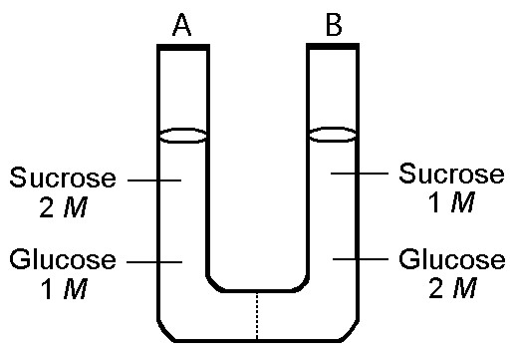

24) The solutions in the two arms of the U-shaped tube shown above are separated by a membrane that is permeable to water and glucose but not to sucrose. Side A contains a solution of concentration 2 M sucrose and 1 M glucose. Side B contains a solution of concentration 1 M sucrose and 2 M glucose. Initially, the liquid levels on both sides are equal.

Initially (before any osmosis or diffusion can take place), in terms of tonicity, the solution in side A with respect to that in side B is
A) hypotonic.
B) plasmolyzed.
C) isotonic.
D) saturated.
E) hypertonic.

25) The solutions in the two arms of the U-shaped tube shown in question 24 are separated by a membrane that is permeable to water and glucose but not to sucrose. Side A contains a solution of concentration 2 M sucrose and 1 M glucose. Side B contains a solution of concentration 1 M sucrose and 2 M glucose. Initially, the liquid levels on both sides are equal.

After any diffusion and/or osmosis has occurred, what changes happen in the U-shaped tube?
A) The molarity of sucrose and glucose are equal on both sides.
B) The molarity of glucose is higher in side A than in side B.
C) The water level is higher in side A than in side B.
D) The water level is unchanged.
E) The water level is higher in side B than in side A.

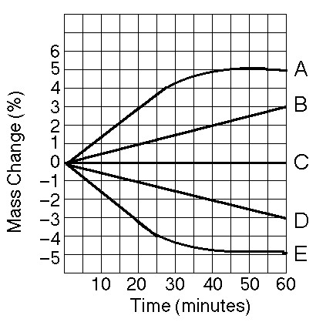

26) Five dialysis bags, constructed from a semipermeable membrane that is impermeable to sucrose, were filled with various concentrations of sucrose and then placed in separate beakers containing a sucrose concentration of 0.6 Molar. At 10-minute intervals, the bags were massed (weighed) and the percent change in mass of each bag was graphed. See the figure above for the change in weight over time for each bag.

Which line in the graph represents the bag that contained a solution isotonic to the 0.6 M solution at the beginning of the experiment?
A) A
B) B
C) C
D) D
E) E

27) See the figure for question 26 to help answer this question. Five dialysis bags, constructed from a semipermeable membrane that is impermeable to sucrose, were filled with various concentrations of sucrose and then placed in separate beakers containing an initial concentration of 0.6 Molar sucrose solution. At 10-minute intervals, the bags were massed (weighed) and the percent change in mass of each bag was graphed. for the change in weight over time for each bag.

Which line in the graph represents the bag with the highest initial concentration of sucrose?
A) A
B) B
C) C
D) D
E) E

28) See the figure for question 26 to help answer this question. Five dialysis bags, constructed from a semipermeable membrane that is impermeable to sucrose, were filled with various concentrations of sucrose and then placed in separate beakers containing an initial concentration of 0.6 Molar sucrose solution. At 10-minute intervals, the bags were massed (weighed) and the percent change in mass of each bag was graphed. See the figure above for the change in weight over time for each bag.

Which line or lines in the graph represent(s) bags that contain a solution that is hypertonic at 50 minutes?
A) A and B
B) B
C) C
D) D
E) D and E

29) A patient has had a serious accident and lost a lot of blood. In an attempt to replenish body fluids, distilled water is transferred directly into one of his veins. What will be the most probable result of this transfusion?
A) It will have no unfavorable effect as long as the water is free of viruses and
bacteria.
B) The patient's red blood cells will shrivel up because the blood fluid has
become hypotonic compared to the cells.
C) The patient's red blood cells will swell because the blood fluid has become
hypotonic compared to the cells.
D) The patient's red blood cells will shrivel up because the blood fluid has
become hypertonic compared to the cells.
E) The patient's red blood cells will burst because the blood fluid has become
hypertonic compared to the cells.

30) An acid (such as HCl)
A) adds H⁺ ions to water
B) increases the pH when added to an aqueous solution.
C) creates a buffer when added to an aqueous solution.
D) is a strong buffer at low pH only.
E) absorbs H⁺ ions.

31) A base (such as OH⁻)
A) adds H⁺ ions to solutions
B) decreases the pH when added to an aqueous solution.
C) creates a buffer when added to an aqueous solution.
D) is a strong buffer at low pH only.
E) removes H⁺ ions from solutions

32) A solution of a substance has a pH of 2. What can you conclude about this substance?
A) It is an acid
B) It is a base
C) It is a buffer

33) A given solution is pH 12. This solution is...
A) acidic.
B) basic.
C) buffered.
D) neutral.

34) A given solution is pH 0. This solution is...
A) acidic.
B) basic.
C) buffered.
D) neutral.

35) A given solution is pH 7.0. This solution is...
A) acidic.
B) basic.
C) buffered.
D) neutral.

36) Which of the following solutions would require the greatest amount of base to be added to bring the solution to neutral pH?
A) gastric juice at pH 2
B) vinegar at pH 3
C) tomato juice at pH 4
D) black coffee at pH 5
E) household bleach at pH 12

37) If the pH of a solution is decreased from 9 to 8, it means that the...
A) concentration of H+ has decreased.
B) concentration of H+ has increased.
C) The H⁺ concentration has not changed, but the concentration of pH has increased.
D) The H⁺ concentration has not changed, but the concentration of pH has decreased.

38) If the pH of a solution is decreased from 1 to 5, it means that the...
A) concentration of H+ has decreased.
B) concentration of H+ has increased.
C) The H⁺ concentration has not changed, but the concentration of pH has increased.
D) The H⁺ concentration has not changed, but the concentration of pH has decreased.

39) Which one of the following statements is true about buffer solutions?
A) They maintain a constant pH when bases are added to them but not when acids are added to them.
B) They maintain a constant pH when acids are added to them but not when bases are added to them.
C) They maintain a relatively constant pH when either acids or bases are added to them.
D) They are found only in living systems and biological fluids.

40) Buffers are substances that help resist shifts in pH by
A) releasing H+ to a solution when acids are added.
B) donating H+ to a solution when bases are added.
C) releasing OH- to a solution when bases are added.
D) accepting H+ from a solution when acids are added.
E) both donating H+ to a solution when bases are added, and accepting H+ when acids are added.

41) Which of the following is not a major buffering molecule in human blood? (more than one correct answer):
A) NaCl
B) H₂O
C) H₂CO₃
D) HCO₃-

42) One of the buffers that contribute to pH stability in human blood is carbonic acid (H₂CO₃) . Carbonic acid is a weak acid that dissociates into a bicarbonate ion (HCO₃-) and a hydrogen ion (H+). This is the chemical reaction:

H₂CO₃ -> HCO₃- + H+

A person eats a food that is basic in pH. As the food molecules enter the blood stream, the buffers in the blood prevent the blood pH from changing in response to the food. Which answer below describes the changes that would occur to the blood's buffering molecules due to the buffering?
A) a decrease in the concentration of H₂CO₃ and an increase in the concentration of HCO₃-.
B) the concentration of bicarbonate ion (HCO₃-) to decrease.
C) the HCO₃- to act as a base and remove excess H+ with the formation of H₂CO₃.
D) the HCO₃- to act as an acid and remove excess H+ with the formation of H₂CO₃.

43) One of the buffers that contribute to pH stability in human blood is bicarbonate ion (HCO₃⁻) . Bicarbonate ion buffers by this reaction:

HCO₃- + H⁺ -> H₂CO₃

A person eats a food that is acidic in pH. As the food molecules enter the blood stream, the buffers in the blood prevent the blood pH from changing in response to the food. Which answer below describes the changes that would occur to the blood's buffering molecules due to the buffering?
A) a decrease in the concentration of H₂CO₃ and an increase in the concentration of HCO₃-.
B) the concentration of bicarbonate ion (HCO₃-) to increase.
C) the HCO₃- to act as a base and remove excess H+ with the formation of H₂CO₃.
D) the HCO₃- to act as an acid and remove excess H+ with the formation of H₂CO₃.

44) When cells make CO₂ during aerobic respiration, the CO₂ enters the blood. In the blood, the CO₂ becomes carbonic acid H₂CO₃. As a result, when CO₂ enters the blood...
A) Blood pH will decrease slightly.
B) Blood pH will increase slightly.
C) Blood pH will remain unchanged.

Answers to multiple choice questions:

1) D
2) C
3) B
4) B
5) A
6) D
7) A
8) D
9) A
10) B
11) B
12) B
13) A
14) A
15) C
16) B
17) C
18) A
19) C
20) B
21) D
22) A
23) E
24) C
25) C
26) C
27) A
28) B
29) C
30) A
31) E
32) A
33) B
34) A
35) D
36) A
37) B
38) A
39) C
40) E
41) A and B
42) A
43) C
44) A

