Review Questions for Math Review topic
Review questions will not be collected and are not worth any points. Doing them will, however, help you prepare for the midterms and quizzes in this course. Furthermore, some of these review questions will appear on the final exam (although the numbers within the questions may be changed).

========================================

1) A patient’s blood hemoglobin concentration was measured over a five day period. The values were (in g/100 mL of blood): 12.9, 12.2, 14.0, 13.0, and 13.8. What was the patient’s range of hemoglobin concentration? _______

2) What is the average hemoglobin concentration for the above patient? ___

3) A survey is taken of the grade point average for 10 students in a Hartnell biology class. The GPA’s are: 2.8, 2.0, 2.9, 2.0, 3.5, 3.4, 3.8, 4.0, 1.9, and 3.6. What is the range of GPAs in the class? ____________.

4) What is the average GPA for this class described problem 3? ________

5) Suppose that 35 students are enrolled in a class, and six of them are late for a midterm. What percent are late for that midterm? ______________%. What percent were not late? __________%.

6) If 130 people take a certain medication and 3 of them experience side effects, what percent experienced side effects? ________ %. What percent did not experience any side effects? _________ %.

7) 95.8% of statistics are not accurate. If a textbook lists 200 statistics, how many of the statistics in the book are not accurate? _______

8) 21% of people surveyed said that they were totally happy with their car. If 2405 people were surveyed, how many were totally happy with their car? __

9) In one year, 91 people in a certain hospital developed a cold or flu while staying in that hospital. Those 91 people represented 7% of all the patients that stayed in the hospital that year. How many people stayed in the hospital that year? ________

10) Only 5% of children experience headaches. If 14 children at a school experience headaches, how may children total go to that school? ______

11) The average heart rate is 72 beats per minute. Louis has a heart rate of 99 beats per minute. What is his percent of average? _________

12) By what percent is Louis’ heart rate above average? ________

13) On average, people have 2.4 colds per year. If Maria has only one cold this year, what is her percent of average? _______

14) By what percent is Maria’s number of colds below average? ________

15) Write 1000 as a power of 10. _______

16) Write 0.00001 as a power of 10. ________

17) Write 10⁵ as a normal number. ________

18) Write 10⁻⁷ as a normal number. ________

19) Write 345 in scientific notation: _________

20) Write 78,000 in scientific notation: _________

21) Write 0.00067 in scientific notation: _________

22) Write 0.5108 in scientific notation: _________

23) Write 8.9 x 10⁻⁴ as a normal number: _________

24) Write 2.01 x 10⁸ as a normal number: _________

25) Write 4.99 x 10⁻⁶ as a normal number: _________

26) Write 5.58 x 10¹ as a normal number: _________

27) Write 5.58 x 10⁰ as a normal number: _________

28) A study compared the amount of aspartame (an artificial sweetener) consumed daily to the concentration of methanol (a type of alcohol that can be formed by the breakdown of artificial sweeteners) in the blood. The results are shown below.

Amount of Concentration of
aspartame consumed (g): methanol in the blood (mg/100 mL)
0 0
0.2 0.3
0.4 0.9
0.8 2.0
1.0 2.3
1.4 2.6

Graph the above data on the graph below. Follow all the proper graphing methods outlined in lab, including proper labeling and numbering of each axis. Under the graph, show the unit conversion factor equations that you used for plotting the points. Lastly, make a best-fit straight line for the points your graphed.


29) A new cancer preventing drug was tested in rats. The amount of the drug that was administered to each rat was compared to the number of tumors induced by exposure to radiation. The following are the data from this study:

Amount of drug given (mg): Number of tumors:
0 58
60 47
120 28
180 20
240 11
300 4

Graph the above data on the graph below. Follow all the proper graphing methods outlined in lab, including proper labeling and numbering of each axis. Under the graph, show the unit conversion factor equations that you used for plotting the points. Lastly, make a best-fit straight line for the points your graphed. Note that this best-fit line will not pass through (0,0).

Answers for Review Questions for Math Review topic:

1) 12.2 – 14.0 g/100 mL.

2) 13.2 g/100 mL.

3) 1.9 – 4.0 GPA.

4) 2.99 GPA.

5) 17%
83%

6) 2.3%
97.7%

7) 191.6 statistics.

8) 505 people.

9) 1300 people.

10) 280 children.

11) 137.5%

12) 37.5% above average.

13) 41.7%

14) 58.3% below average. (100% - 41.7%).

15) 10³

16) 10⁻⁵

17) 100,000

18) 0.0000001

19) 3.45 x 10²

20) 7.8 x 10⁴

21) 6.7 x 10⁻⁴

22) 5.108 x 10⁻¹

23) 0.00089

24) 201,000,000

25) 0.00000499

26) 55.8

27) 5.58

28) (Note: There are several ways to correctly number the graph axis. The graph below shows just one correct way. As long as each axis has a zero, and is numbered such that the highest data value is plotted at least half way along the axis, and that the exact data values are not shown on the axis itself, the axis is numbered correctly).
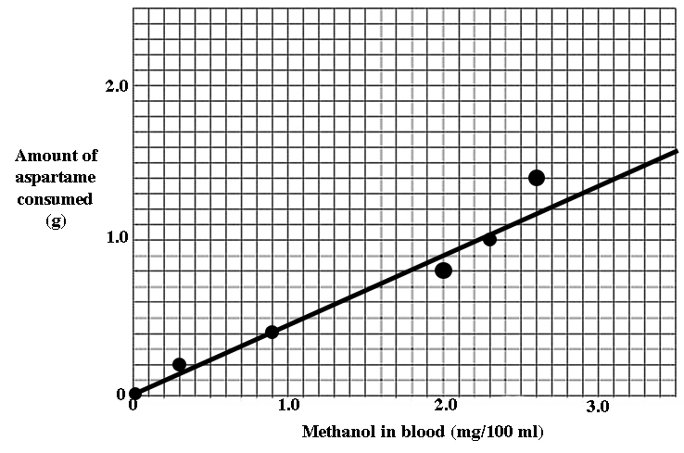

Aspartame data:
0 g x (20 lines/ 2 g aspartame) = 0 lines
0.2 g x (20 lines/ 2 g aspartame) = 2 lines
0.4 g x (20 lines/ 2 g aspartame) = 4 lines
0.8 g x (20 lines/ 2 g aspartame = 8 lines
1.0 g x (20 lines/ 2 g aspartame) = 10 lines
1.4 g x (20 lines/ 2 g aspartame) = 14 lines

Methanol data:
0 mg/100 ml x (30 lines/3 mg methanol/100 ml) = 0 lines
0.3 mg/100 ml x (30 lines/3 mg methanol/100 ml) = 3 lines
0.9 mg/100 ml x (30 lines/3 mg methanol/100 ml) = 9 lines
2.0 mg/100 ml x (30 lines/3 mg methanol/100 ml) = 20 lines
2.3 mg/100 ml x (30 lines/3 mg methanol/100 ml) = 23 lines
2.6 mg/100 ml x (30 lines/3 mg methanol/100 ml) = 26 lines

29) (Note: There are several ways to correctly number the graph axis. The graph below shows just one correct way. As long as each axis has a zero, and is numbered such that the highest data value is plotted at least half way along the axis, and that the exact data values are not shown on the axis itself, the axis is numbered correctly).
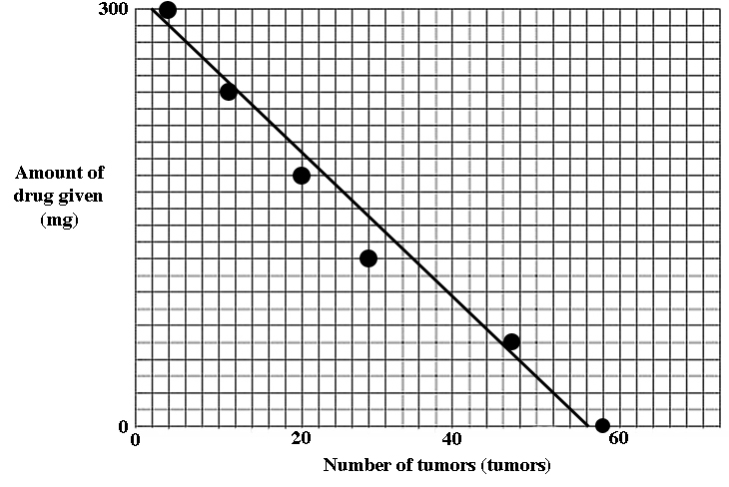

Drug given data:
0 mg x (25 lines/300 mg) = 0 lines
60 mg x (25 lines/300 mg) = 5 lines
120 mg x (25 lines/300 mg) = 10 lines
180 mg x (25 lines/300 mg) = 15 lines
240 mg x (25 lines/300 mg) = 20 lines
300 mg x (25 lines/300 mg) = 25 lines

Tumor number data:
58 tumors x (30 lines/60 tumors) = 29 lines
47 tumors x (30 lines/60 tumors) = 23.5 lines
28 tumors x (30 lines/60 tumors) = 14 lines
20 tumors x (30 lines/60 tumors) = 10 lines
11 tumors x (30 lines/60 tumors) = 5.5 lines
4 tumors x (30 lines/60 tumors) = 2 lines

