Review Questions for Unit Conversion Factors topic
Review questions will not be collected and are not worth any points. Doing them will, however, help you prepare for the midterms and quizzes in this course. Furthermore, some of these review questions will appear on the final exam (although the numbers within the questions may be changed).

For all review questions in this document, use the unit conversion factor method and clearly show all the appropriate units canceling.
========================================

1) Make a pair of unit conversion factors for converting seconds to minutes.

2) A study is done to see the health effect of a drug of aspirin on humans. Each person in the study received 15 milligrams of the drug. If 150 people participate in the study, how many milligrams of the drug are needed? Use the unit conversion factor method and show all your work.

3) Gold costs $1047 per ounce. A solid gold nugget is 0.56 ounces. How much is it worth? Use the unit conversion factor method and show all your work.

4) Dr. Hyde orders 48 milligrams of medication for a patient. Each pill contains 2.5 milligrams of the medicine. How many pills will the patient need? (Note: When dispensing medicine, if the calculation answer contains a fraction of a pill (such as 52.6 pills) health workers usually round down so as to avoid any chance of overdosing the patient). Use the unit conversion factor method and show all your work.

5) How many hours are 12560 seconds? Use the unit conversion factor method and show all your work.

6) Dr. Katz prescribes 200 mg of medicine per kilogram of body weight to a patient. Each pill has 1600 mg of medicine. The patient weighs 75 kilograms. How many pills will the patient need? Use the unit conversion factor method and show all your work.

7) How many inches is this crayon? Use the unit conversion factor method and give your answer in decimals (not fractions).
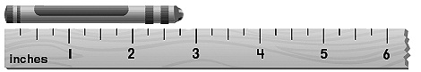

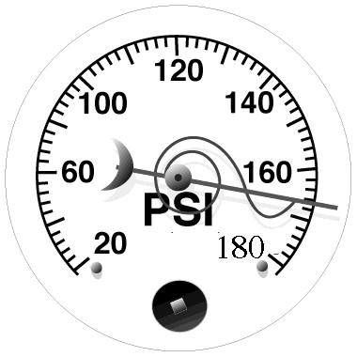

8) How many PSI does this gauge read?
Use the unit conversion factor method and
give your answer in decimals.

9) What is the volume of water in this
graduated cylinder (in mL)? Use the unit
conversion factor method and give
your answer in decimals.
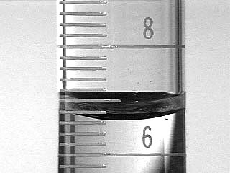

Inspect the graph below, then answer review questions 10 - 15.
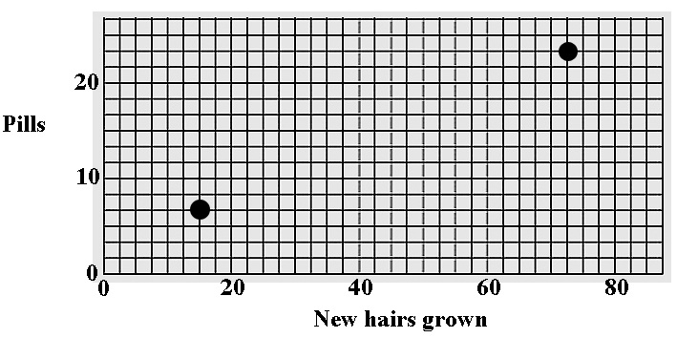

10) Write the two unit conversion factors for the Y-axis.

11) Write the two unit conversion factors for the X-axis.

12) How many pills and how many nose hairs does the lower data point represent? Show your work using the unit conversion factor equations.

13) How many pills and how many nose hairs does the upper data point represent? Show your work using the unit conversion factor equations.

14) Make a point on the graph that represents 12 pills and 27.5 nose hairs. Show your work using the unit conversion factor equations.

15) Make a point on the graph that represents 17 pills and 65 nose hairs. Show your work using the unit conversion factor equations.

Answers for Review Questions for Unit Conversion Factors topic

1) 60 seconds/1 minute and 1 minute/60 seconds

2) 150 people x (15 mg/person) = 2250 mg

3) 0.56 ounces x ($1047/ounce) = $586.32

4) 48 mg x (1 pill/2.5 mg) = 19 pills

5) 12560 seconds x (1 minute/60 seconds) x (1 hour/60 minutes)
= 3.49 hours

6) 75 kg x (200 mg/kg) x (1 pill/1600 mg)
= 9 pills

7) Length = 2 inches + (3 graduations) x (1 inch/4 graduations)
= 2.75 inches

8) PSI = 160 PSI + (3 graduations) x (20 PSI/10 graduations)
= 166 PSI

9) Volume = 6 mL + (3 graduations) x (2 mL/10 graduations)
= 6.6 mL

10) (10 pills/6 lines) and (6 lines/10 pills)

11) (20 hairs/8 lines) and (8 lines/20 hairs)

12) Pills = 4 lines x (10 pills/6 lines) = 6.6 pills
Nose hairs = 6 lines x (20 hairs/8 lines) = 15 hairs

13) Pills = 14 lines x (10 pills/6 lines) = 23.3 pills
Nose hairs = 29 lines x (20 hairs/8 lines) = 72.5 hairs

14) 12 pills x (6 lines/10 pills) = 7.2 lines on Y-axis
27.5 hairs = (8 lines/20 hairs) = 11 lines on X-axis
This point is light gray dot on the graph below.

15) 17 pills x (6 lines/10 pills) = 10.2 lines on Y-axis
65 hairs = (8 lines/20 hairs) = 26 lines on X-axis
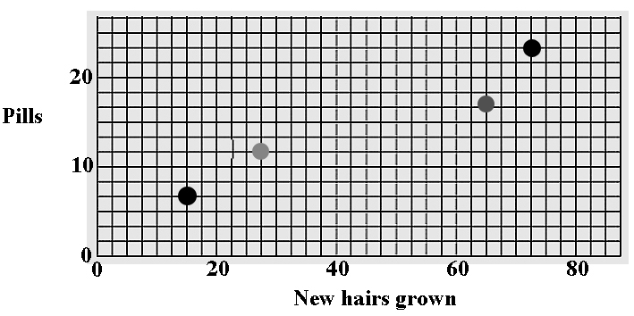
This point is dark gray dot on the graph below.

