Review Questions for WBC counts topic
Review questions will not be collected and are not worth any points. Doing them will, however, help you prepare for the midterms and quizzes in this course. Furthermore, some of these review questions will appear on the final exam (although the numbers within the questions may be changed).
==============================

1) The major job of the immune system is to protect us from _______, a term that means organisms that cause disease.
A) Antigens
B) Pathogens
C) Antibodies
D) Trauma

2) Although there are many types of pathogens, the two most common types are (two answers)
A) Cigarette smoke
B) Poisons
C) Viruses
D) Bacteria
E) Cholesterol/Heart disease

3) The term _______ means invasion of the body by pathogens
A) Infection
B) Illness
C) Cancer
D) Trauma

4) Antigen
A) A medicine given to heart attack victims to restore blood flow
B) A type of leukocyte
C) The molecules on the surface of a cell that the immune system interacts with
D) A medicine given to heart attack victims to counteract blood poisonings (such
as snake bites or peanut allergy reactions)

5) The term ________ means all antigens that do not occur naturally in the body
A) Viral antigens
B) Protein antigens
C) Anti-antibody antigens
D) Foreign antigens

6) The term _____ means all the white blood cell types
A) Leukocyte
B) Formed elements
C) Lymphocyte
D) Blood
E) Plasma

7) How many major WBC types are there?
A) 3
B) 5
C) 8
D) 10

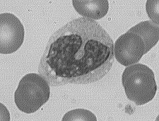
8) In lab, you identified WBC types
under the microscope. What WBC type
is shown on the right?
A) Monocyte
B) Eosinophil
C) Lymphocyte
D) Neutrophil
E) Basophil

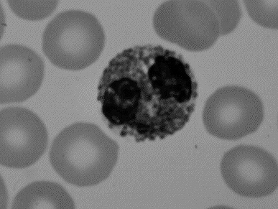

9) In lab, you identified WBC types
under the microscope. What WBC
type is shown on the right? Hint: It
has large red granules.
A) Monocyte
B) Eosinophil
C) Lymphocyte
D) Neutrophil
E) Basophil

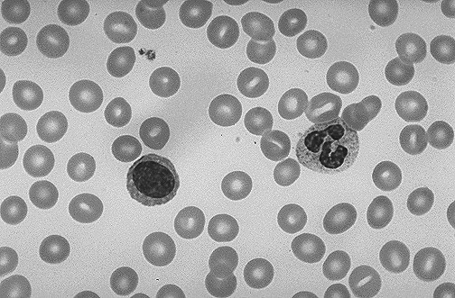
10) In lab, you identified WBC
types under the microscope. What
WBC type is shown on the left side
of this image?
A) Monocyte
B) Eosinophil
C) Lymphocyte
D) Neutrophil
E) Basophil

11) In lab, you identified WBC
types under the microscope. What
WBC type is shown on the right
side of this image?
A) Monocyte
B) Eosinophil
C) Lymphocyte
D) Neutrophil
E) Basophil

12) The term ______ means one cell engulfing (eating) another cell
A) Phagocytosis
B) Consummation
C) Lysis
D) Hemolysis

13) What substance do basophil cells release?
A) Antigens
B) Clotting factors
C) Antibodies
D) Histamine

14) WBCs that do phagocytosis include all of the following except
A) neutrophils
B) basophils
C) macrophages
D) eosinophils

15) The proteins that tear apart the membranes of antibody-coated pathogen cells
A) Antibodies
B) T-cells
C) Complement
D) Free radicals

16) Which things below are lymphocytes or made by lymphocytes? (More than one correct answer).
A) Basophil cells
B) B cells
C) Toxins
D) T cells
E) Neutrophil cells
F) Eosinophil cells
G) Platelets
H) Antibodies

17) Which of the following are parts of the humoral immune system? (More than one correct answer).
A) B cells
B) Antibodies
C) T cells
D) Basophils
E) Neutrophils

18) Which of the following is part of the cell-mediated immune system?
A) B cells
B) Antibodies
C) T cells
D) Basophils
E) Neutrophils

19) True or false: The B cells and T cells that attack the flu virus would also be able to attack the virus that causes the common cold.
A) True
B) False

20) True or false: B cells and T cells that attack this year’s flu virus would also be able to attack last year’s flu virus.
A) True
B) False

21) Which function is a characteristic of B cells?
A) Releasing histamine
B) Formation of antibodies
C) Generating digestive enzymes for pathogen lysis
D) Phagocytosis

22) Which is not true of antibodies
A) They are found in the plasma
B) They are part of cell-mediated immune system
C) They are proteins
D) They are Y-shaped

23) Antibodies
A) Are present on all cells (cells of the body and pathogen cells)
B) Are made by pathogen cells, inside or outside the body
C) Bind to foreign pathogens
D) Are released by basophils

24) Cells linked together by antibodies are said to be
A) Agglutinated
B) Polymerized
C) Macromolecules
D) Antigens

25) When a B cell or T cell encounters the foreign antigen that it is against, the B or T cell will divide repeatedly to make copies of itself. This process is called
A) Metastasis
B) Mitosis
C) Binary fission
D) Clonal expansion
E) Cancer

26) The normal total WBC count range for a healthy adult is
A) 50 WBC/mm³
B) 80 – 120 WBC/mm³
C) 4 – 6 million WBC/mm³
D) 5000 – 10,000 WBC/mm³

27) Which statement about complement proteins is false?
A) Complement proteins are present in plasma even during times of no
infection
B) They are activated by T cells
C) They attack cells covered by antibodies
D) They lyse (break open) pathogen cells

28) Cytotoxic T cells
A) Make antibodies
B) Inject pathogens with toxins
C) Engulf pathogens by phagocytosis
D) Destroy self-antigens/cause autoimmune disease cells

29) The cells that do “clonal expansion” are
A) B and T lymphocytes
B) Bacteria that enter the body before the immune system controls their growth
C) All immune cells
D) Cancer cells

30) Define these terms as they were defined in class

a) Pathogen

b) Antigen (define the term and also explain the difference between self antigens
and foreign antigens)

c) Phagocytosis

d) Leukocytes

e) Histamines

f) Antibody

g) Humoral immune system

h) Agglutination

i) Clonal expansion

j) Leukocytosis

k) Leukopenia

l) Cell mediated immune system

31) The immune system defends the body from ________, a term that means living things that cause disease.

32) The term _______ means when pathogens have entered the body.

33) The two most common pathogen types are ______ and _______.

34) ________ (a pathogen type) are small cells. They have a metabolism, a chromosome, and they reproduce by dividing themselves into two new cells.

35) ______ (a pathogen type) are the smallest pathogen type. They are not cells. They have no metabolism or cell membrane. They can only reproduce by entering the inside of the body’s cells, and then tricking the cell into make copies of themselves.

36) A(n) _____ is any molecule that the immune system interacts with; usually these molecules are proteins, carbohydrates, and lipids on the surface of cells.

37) The antigens that are made naturally as part of the body are called _______, whereas the antigens that are not made naturally as part of the body (such as the antigens on pathogens) are called _______.

38) The cells of the immune system attack all cells that have _______ antigens, but the immune cells do not attack any cells that have ______ antigens. Rarely, however, the immune system makes a mistake and attacks the body’s own cells. This is called a(n) _________________ disease. List an example autoimmune disease: _____________.

39) _____ are all the blood cells that are part of the immune system. These cells are also called ______.

40) There are _____ (a number) major types of white blood cells.

41) The five major types of white blood cells are: _____, _____, _____, _____, and _____.

42) White blood cells are sometimes divided into two groups, depending on whether they have granules in their cytoplasm or not. Those WBCs that have granules are called _____ and those WBCs that do not have granules are called _____.

43) There are three types of granulocytes: _____, _____, and _____.

44) There are two types of agranulocytes: _____ and _____.

45) The two most abundant types of leukocytes are _____ are _____: the remaining three types account for 10% or less of total number of leukocytes.

46) Name the WBC cell type(s) that…(some blanks may require more than one answer)
a) Can have a nucleus with two lobes: _________
b) Can have a nucleus with three lobes: __________
c) Can have a kidney-bean shaped nucleus: ___________
d) Can have a large round nucleus: _________
e) Has large red granules: __________

47) Any molecules on cells that the immune system interacts with are called __________. They are usually proteins, carbohydrates, or lipids on the surface of a cell.

48) Molecules on cells that the immune system interacts with but does not attack (because the molecules occur naturally as part of the organism) are called _________.

49) Molecules on cells that the immune system interacts with and attacks (because the molecules do not occur naturally as part of the organism) are called _________.

50) Pathogens that enter the body can be engulfed (“eaten”) by white blood cells, a process known as _______.

51) The three phagocytes of the immune system are _____, _____, and _____. Circle the one that does the least phagocytosis of the three.

52) The main function of neutrophils is _____.

53) Neutrophils can be recognized by their nuclei, which generally have _____ (a number range) of lobes.

54) Basophils can be recognized by their nuclei, which generally have _____ (a number) of lobes.

55) Lymphocytes can be recognized by their nuclei which are usually _____ or ______ shaped.

56) _____cells, which develop from monocytes, are the most voracious of the phagocytes.

57) Monocytes can be recognized by their size (they are usually smaller/larger (circle one) compared to other blood cells) and by the _____ shape of their nucleus.

58) Basophils release _____, which is a molecule that dilates blood vessels and makes the blood vessel leaky so that the immune system cells can exit the blood vessel and attack pathogens outside the blood.

59) In addition to albumin protein, the blood contains large amounts of ______ which
are proteins needed to protect the body from invaders, and ______ proteins which are needed for blood clotting.

60) Antibodies are also known as ____________.

61) Any overabundance of white blood cells is known as ________.
62) The most common cause of leukocytosis is ___________.

63) The photo below shows a blood sample when viewed through a microscope. What blood cell type are the small gray circles with nothing visible inside? _________ What cell type is the large cell on the left with the black lobed nucleus? __________ What cell type is the large cell on the right with the black round nucleus? __________ Be as specific as possible in all answers.

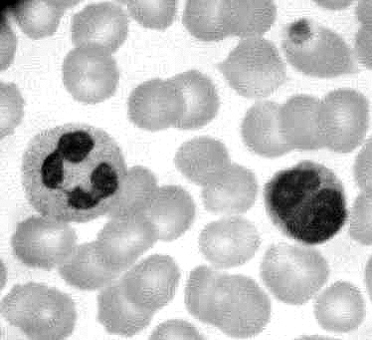

64) _____ refers to bone cancer that results in abnormally high levels of white blood cells. If untreated, these cancers are always fatal.

65) The ______ is a set of proteins present in the blood that, when activated, lyse pathogen cell membranes.

66) Of the five major types of white blood cells, only one type, the ______, have cells that are individually programmed to defend the body against specific pathogens.

67) The two major types of lymphocytes are _____ cells and ______ cells.

68) Each individual lymphocyte cell can recognize and attack one/many (circle one) type(s) of foreign antigens. Since there are thousands of different pathogens that could potentially infect the body, there are one /many (circle one) different lymphocytes.

69) Thanks to clonal expansion of B cells and T cells, we have a much stronger and faster immune response against a pathogen we have encountered before. This phenomena is called the ______ of the immune system.

70) For the lymphocytes to mount a specific defense against a newly encountered pathogen takes _____ (how long?). This response is slow because at the beginning of the infection there may be only a single lymphocyte in the body that happens to bind to that particular pathogen. To effectively fight the pathogen, that single cell has to make millions of copies of itself. This process is called _________________.

71) Re-exposure, even years later, to a foreign antigen that has been responded to before results in a specific defense that takes _____ (how long?) to mount. This is due to the presence of many B and T cells against the antigen made by clonal expansion during the first encounter with the pathogen.

72) ______ are Y-shaped molecules in the blood that bind antigens.

73) Antibodies are _____ (one of the four types of macromolecules).

74) _____ are the lymphocytes that make and secrete antibodies.

75) When a B lymphocyte has encountered its foreign antigen (the specific foreign antigen that the B cell is programmed to respond to) the B cell begins to reproduce itself, a process that is called _______ of the lymphocyte.

76) When a B-cell encounters the foreign antigen that it is programmed to fight, it begins to secrete antibodies against that antigen. The B cell that is secreting antibodies is sometimes called a ___________ cell.

77) When a lymphocyte (such as a B cell) does clonal expansion, the all the new cells it produces do/do not (circle one) have the same specificity for the same antigen as the original cell that clonally expanded.

78) The antibodies attached to a pathogen slow the spread of the infection in many ways: The antibodies attached to the pathogen simply "get in the way," so to speak, interfering with the functioning of the pathogen cell. Another way that the antibodies fight the pathogen is by linking several pathogens together. The term _____ means when cells are linked together by antibodies

79) Each antibody can simultaneously bind to _____ (how many?) identical antigens. This is what allows antibodies to agglutinate pathogens containing foreign antigens.
80) Antibodies bound to a pathogen trigger attacks on that pathogen by _____ proteins, which are proteins in the blood that can lyse (tear open) cells.

81) The complement proteins only destroy cells that have antibodies attached to their antigens. This prevents the complement proteins from attacking _____.

82) B cell lymphocytes and the antibodies they make are together called the ______ (or antibody-mediated) immune system.

83) _____ are the lymphocytes that attack pathogen cells by direct cell-to-cell contact (unlike B cells, which attack pathogens indirectly by releasing antibody proteins).

84) Killer T-cells attack pathogen cells by direct cell-to-cell contact. The killer T cell contacts the pathogen cell then injects the pathogen cell with _______.

85) Some T cells are _____ T cells, which are necessary for B and T lymphocytes to undergo clonal expansion.

86) The branch of the specific immune system that is carried out by T cell lymphocytes is called the ________ immune system because living cells (T cells, macrophages, and pathogen cells) are all required for its functioning.

87) After each description, write B if it describes a B cell, write T if it describes a T cell. Some blanks may require more than one answer.

a) Lymphocytes: _____

b) Makes antibodies: _____

c) Part of the humoral immune system: _____

d) Part of the cell-mediated immune system: _____

e) It works with the complement proteins to destroy pathogen cells: _____

88) One way that we medically enhance the immune response against a specific pathogen is to inject a person with non-living antigens from the pathogen (or in some cases, a weakened but living form of the pathogen). This procedure is called a(n) ______. The person will not become sick if they encounter the true pathogen because their immune system has already _________ (done what?).

89) You receive a flu shot (a vaccination against that year’s flu virus). A few months later, you are exposed to a person with the flu. Thanks to the flu shot, your body is able to fight off the virus so quickly that you never feel ill. Why do you have to get the flu shot again next year? Be as specific as possible in your answer.

90) Name the possible causes of leukocytosis that were mentioned in class.

91) Name the possible causes of leukocpenia that were mentioned in class.

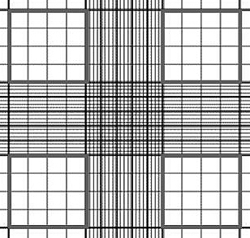
92) The figure on the right shows
the entire grid on the
hemocytometer. Draw an X on
all square regions of the figure that
you count to do a total WBC count.

93) A differential WBC count was done on a patient’s blood sample. The results are shown below. Use the table of normal differential WBC count percentage values and the Clinical Applications box (both of which are in your lab manual, in exercises 6.1 and 6.2) diagnose all possible diseases that the patient might have.

Neutrophils = 56% Eosinophils = 4% Basophils = 1%
Monocytes = 12% Lymphocytes = 26%

94) Each of the four figures below shows one of the squares that were counted in a total WBC count. Using the same methods of counting and calculation that you used in lab, calculate the total WBC count for the blood sample. Be sure to include the correct units in your answer ________. Would this WBC count be within the normal range for a patient? ________. If not, does the patient have leukocytosis or leukopenia? _________.
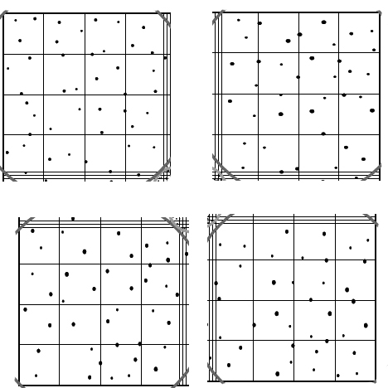

==================

Answers for Review Questions for WBC Counts topic:

1) B

2) C and D

3) A

4) C

5) D

6) A

7) B

8) A

9) B

10) C

11) D

12) A

13) D

14) B

15) C

16) B, C, D, and H

17) A and B

18) C

19) B

20) B

21) B

22) B

23) C

24) A

25) D

26) D

27) B

28) B

29) A

30) a) Any living thing that can cause disease.

b) Molecules that the immune system interacts with. Usually, these are the proteins, carbohydrates, and lipids on the surface of cells. Self antigens are the antigens that occur naturally in the body. Foreign antigens are antigens that do not occur naturally in the body.

c) One cell engulfing (eating) another cell

d) The blood cells that are part of the immune system. They are also known as
white blood cells (WBCs).

e) Molecules that are released from basophil WBCs. Histamines cause the walls
of capillaries to become leaky.

f) A Y-shaped protein made by B cells that binds to foreign antigens on
pathogens.

g) The B cells and the antibodies they secrete.

h) Antibodies linking cells together.

i) Lymphocyte cells reproducing only when they have been exposed to the exact
antigen that they are against.

j) Total WBC count above the normal range of 5000 – 10000 WBCs/mm³.

k) Total WBC count below the normal range of 5000 – 10000 WBCs/mm³.

l) The Cytotoxic T cells (also known as killer T cells)

31) Pathogens

32) Infection

33) Viruses
Bacteria

34) Bacteria

35) Viruses

36) Antigens

37) Self antigens
Foreign antigens

38) Foreign antigens
Self antigens
Autoimmune disease
Multiple sclerosis, Lupus, or Rheumatoid arthritis

39) Leukocytes
White blood cells (WBCs)

40) Five

41) Neutrophils
Eosinophils
Basophils
Monocytes
Lymphocytes

42) Granulocytes
Agranulocytes

43) Neutrophils
Eosinophils
Basophils

44) Monocytes
Lymphocytes

45) Neutrophils
Lymphocytes

46) a) Neutrophils, eosinophils, and basophils

b) Neutrohils

c) Monocytes and lymphocytes

d) Lymphocytes

e) Eosinophils

47) Antigens

48) Self antigens

49) Foreign antigens

50) Phagocytosis

51) Neutrophils
Eosinophils
Macrophages (which come from monocytes)

52) Phagocytosis

53) 2 – 5 lobes

54) 2 lobes

55) Round or kidney bean shaped

56) Marcophages

57) Larger
Kidney bean

58) Histamine

59) Antibodies
Clotting proteins

60) Immunoglobulins

61) Leukocytosis

62) Infection

63) RBCs
Neutrophil
Lymphocyte

64) Leukemia

65) Complement proteins

66) Lymphocytes

67) B cells
T cells

68) One
Many

69) Memory

70) About two weeks
Clonal expansion

71) A day or two

72) Antibodies

73) Proteins

74) B cells

75) Clonal expansion

76) Plasma cell

77) Do

78) Agglutination

79) Two

80) Complement

81) The body’s own cells

82) Humoral immune system

83) Cytotoxic T cells

84) Toxins

85) Helper

86) Cell mediated immune system

87) a) B and T

b) B

c) B

d) T

e) B

88) Vaccination
Immunization
Clonally expanded

89) A flu shot causes clonal expansion only of the lymphocytes against the exact strain of the influenza virus that was in the vaccination. The flu that comes next year is usually a different strain of the influenza virus than the one that appeared the previous year, and therefore a new shot is needed to cause clonal expansion of the lymphocytes against the new strain of the virus.

90) Fighting an infection
Surgery/Injuries
Allergies
Leukemia

91) Certain viral infections
Autoimmune diseases
Stress
Chemotherapy

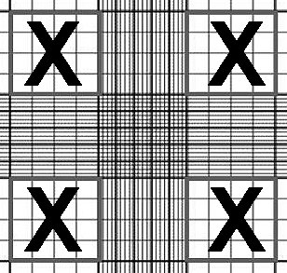
92)

93) The percentages that are given in the problem for the five major WBC types are all within their normal ranges, with the exception of the monocytes. The problem lists the patient’s monocyte percentage as 12% of the WBCs, but the normal range for monocytes (according to the table in the lab manual) is 3% - 8% of the WBCs. Since the patient has a monocyte count that is above the normal percentage, the patient is said to have monocyte leukocytosis. Referring to the Clinical Applications box in the lab manual, monocyte leukocytosis can be a symptom of malaria, Rocky Mountain spotted fever, bacterial endocarditis, or typhoid fever.

94) These are the approximate counts for each of the four counting squares shown. Your counts may differ slightly from the counts given below, but they should agree within +/-3 WBCs in each square. (Remember to not count WBCs that are touching the right or bottom of each counting square).

(a) 40 (b) 37 (c) 39 (d) 38

The WBC count is calculated by adding the four counting squares then multiplying by a factor of 50:

40 + 37 + 39 + 38 = 154

154 x 50 = 7700 WBCs/mm³

A total WBC count of 7700 WBCs/mm³ is within the normal range. The patient does not have leukocytosis or leucopenia.

